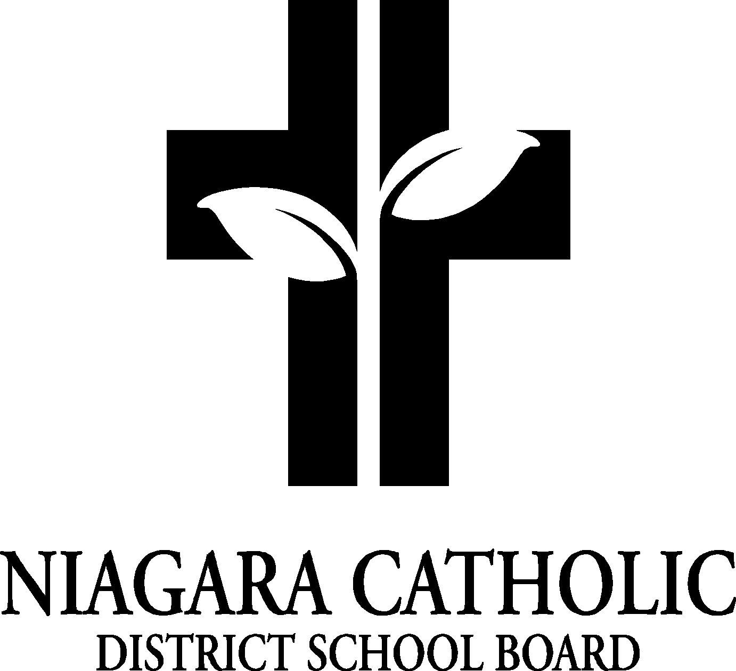

**MINUTES OF THE**

**ST PHILOMENA** **CATHOLIC SCHOOL COUNCIL MEETING**

September 29, 2020

The meeting was called to order at 6:15pm by Nila Lampman

1. **A. ROUTINE MATTERS**
2. Opening Prayer - led by Mr. Chris Spagnol
3. Roll Call

| **CATHOLIC SCHOOL COUNCIL MEMBERSHIP** | | Present | Excused | Absent |
| --- | --- | --- | --- | --- |
| Principal/Treasurer/SEAC Rep. | Mr. Chris Spagnol | **X** |  |  |
| Chair/Bingo Treasurer | Mrs. Nila Lampman | **X** |  |  |
| Co-Chair | Mrs. Diana Maskell | **X** |  |  |
| Teacher Representative | Mrs. Amy Heximer | **X** |  |  |
| Parish/Community/OAPCE Rep. Representative |  |  |  |  |
| Recording Secretary | Katrina Paradise | **X** |  |  |
| Bingo Co-Ordinator | Mrs. Angie Pijl | **X** |  |  |
| **PARENT REPRESENTATIVES** | | | |  |
| Jennifer Crowley | |  | **X** |  |
| Melissa Stack | | **X** |  |  |
| Kristin Pisaric | |  | **X** |  |
| Carrie Gordon | |  | **X** |  |
| David VanKoughnett | | **X** |  |  |
| Laura VanKoughnett | | **X** |  |  |
| Cheri LaChance | |  | **X** |  |
| Tara Felt | |  | **X** |  |
| Jaime Fiegle-Fowler | | **X** |  |  |
| Adam Fowler | | **X** |  |  |
| Heather Gignac | |  | **X** |  |
| Lizz McCooey | |  | **X** |  |
| Joyce Elson | |  | **X** |  |
| Devon Ahern | |  | **X** |  |
| Diane LeBar | |  | **X** |  |
| Krystal Kwakernaat | | **X** |  |  |
| Kristen Saari | |  | **X** |  |
| Sarah Collee | | **X** |  |  |

1. Approval of the Agenda of the St. Philomena Catholic School Council Meeting of September 29th, 2020 VIA Zoom.

Motion: Diana Second by: Melissa

THAT Council approve the Agenda of the St. Philomena CSC Meeting of the September 29th, 2020 VIA Zoom.

CARRIED

Disclosure of Interest

No Disclosures of Interest were declared with any items on the agenda.

Approval of Minutes of the St. Philomena Catholic School Council Meeting of January 28th, 2020.

Motion: Diana Second by: Missy

THAT Council approve the minutes of the St. Philomena CSC Meeting of January 28th, 2020.

CARRIED

**B. PRESENTATIONS**

1. NIL

**C. PRINCIPAL’S REPORT**

1. St. Philomena Catholic School Council Bylaws Review – Chris will distribute to the group

2. Bingo Financials

Year end 2019/20 closing balance $4216.83

Fiscal year 2020/21 opening balance $4216.83

3. Catholic School Council Elections

*Recording Secretary

Welcome Katrina Paradise as our new 2020 Catholic School Council Secretary!

4. Catholic School Council Financials

Hot Lunch Balance: $5061.20

Fielding Balance: $2909.15

CSC Raffle: $1563.21

5. Niagara Catholic Parent Involvement Committee (NCPIC) Report

* **NIAGARA CATHOLIC PARENT INVOLVEMENT COMMITTEE NOMINATIONS 2020-2021**
* Parents/Guardiansnomination forms must be received no later than **4:00 p.m. EST., on *Friday, October 9, 2020.***



***Niagara Catholic Parent Involvement Committee***



**NCPIC 2020-2021 Meeting Dates:**

November 5, 2020 (Commissioning of 2020-2021 NCPIC Members, and Terms of Office)

January 7, 2021

March 4, 2021

May 6, 2021

6. Special Education Advisory Committee (SEAC) report

7. Policy Vetting all available online: <https://niagaracatholic.ca/policies-by-laws-protocols-and-procedures/>

* + Dress Code-Secondary Uniform Policy (302.6.6)
  + Elementary Standardized Dress Code Policy (302.6.10)
  + Niagara Catholic Parent Involvement Committee Policy (800.7)
  + Accessibility Customer Service Policy (800.8.1)
  + Complaint Resolution Policy (800.3)

8. School Improvements

-Parking Lot and Kindergarten Pen

-Painted School Interior

-New Exterior Doors

-Sensory Hallway

-Outdoor Basketball Nets

-Chromebooks (13) – still in need of more Chromebooks and/or iPads – note that funds from

BINGO can no longer be spent on technology

-New Desks and Chairs (30)

**D. CHAIR/ CO-CHAIR REPORT**

- CSC lunch days – postponed until further notice

- Compost bins – postponed until further notice

- Snack program – still present but will look different this year – more a grab and go program.

-Possibility of doing a school wide “snack drive”

-Lococos does have single serve veggie options – price out

- Volunteering: Kiss and Ride -postponed until further notice

- Fundraiser decision

-Diana, Nila and Mr. Spagnol will work with Fielding Wine and the Fort Erie Soccer

Club (as the pick up point) in hopes of having an early December delivery date

-Pizza Night/Movie Night/Trivia Night – Melissa, Diana and Nila will coordinate with

Mr. Spagnol to put together a package for this and list on School Cash online

**E. OAPCE REPORT-**

**F. STAFF REPORT**

1. Orange Shirt Day: Sept 30
2. Halloween Celebration: October 30

**G. AGENDA ITEMS / DISCUSSION FOR FUTURE MEETING**

1. Annual Plan – Mr. Spagnol will disperse to CSC

**H. NEXT MEETING** – November 24th, 2020 – Virtual at 6:15pm – will email out invitation

**I. ADJOURNMENT 7:15**

**J. CLOSING PRAYER**